CHINESE FLAGSHIP SECONDARY CURRICULUM
Level 3 Stamps
UNIT 5: Teen’s World

Name: | Class Period:

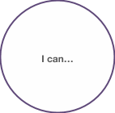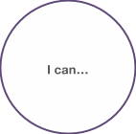
I can describe what my day looks like
I can interact and exchange information with my peers on the social media
I can share my experience or opinions on the social media
I can talk about my choices of college education and why
I can understand and chip in some ideas when my peers are sharing their plans for college
I can fill out or create a college/summer job resume
I can share my plan for the future with my peers
I can talk about my preferences in lifestyles, trends and fashions
I can understand my friend’s plans/expectations of their plan after high school
I can illustrate my ideas of my college life and expectations
I can understand some topic articles about the world of teens
I can write a college cover letter
I can …
I can understand the job description and some details on a job ad
I can support my choices and ideas of college education and career
I can write an email about my teen’s life to my counterpart in China
I can answer questions in a short job interview
I can …
I can …
I can …
I can illustrate the generation gap between my parents and me
I can describe my own personality and others’
I can …

Can do without help ____ (2) | Can do it with help _____ (1) | Need to learn _____
Adapted from Jefferson County Public Schools, KY, 2011

